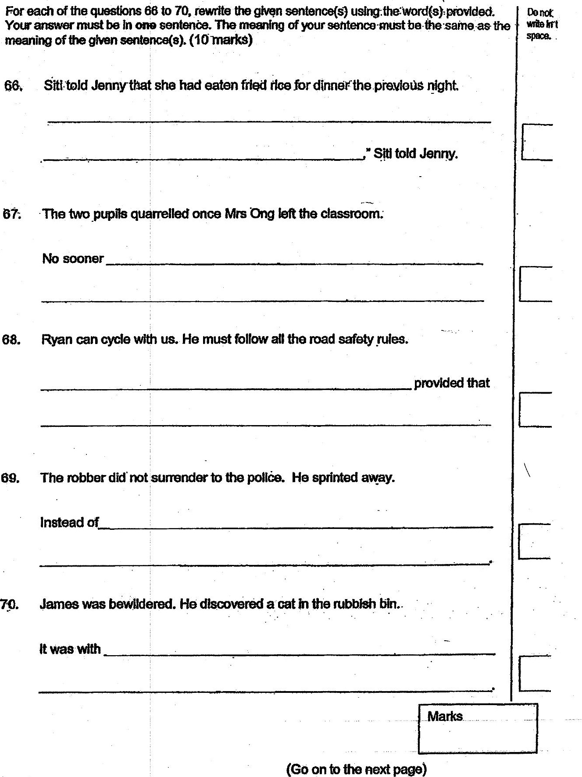

67: The two pupils quarrelled once Mrs Ong left the classroom.